**EC2 Documentation**

**Step 1 : Creating a EC2 Instance**

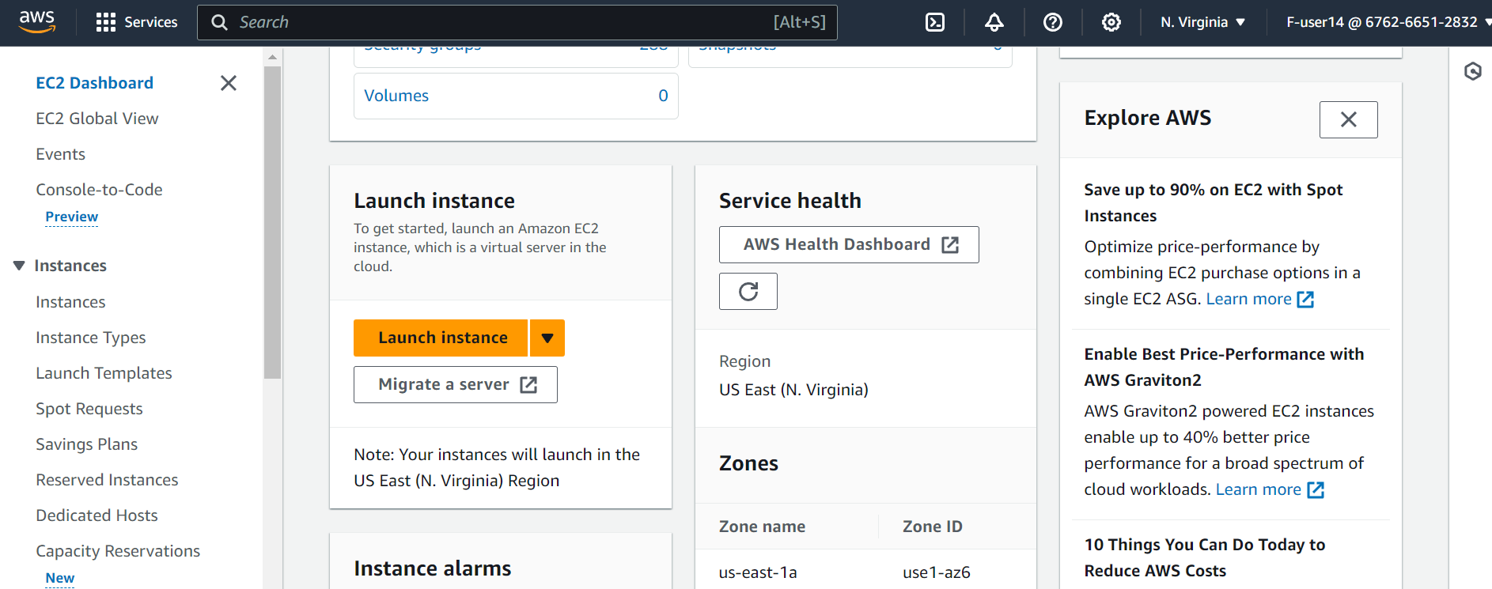

**

**Step 3 : Using SSH to connect with EC2**

**Step 4 : Installing Java on the EC2**

Command : Sudo yum install java-17-amazon-corretto

**Step 5: Making jars of microservices**

**Step 6: Creating a S3 Bucket and uploading jars**

**Step 7: Running the jar in EC2**

